Name:
Independent Reading Project

“Own your own reading”-Mr. Washerstein

Introduction: The Independent Reading Project is a chance for you to explore a novel of your choosing! You have been asked to read a minimum of 30 minutes each evening. This project is geared towards fostering a student community that appreciates reading on a regular basis. We will also be focusing on vocabulary acquisition, summarization skills, and presentation skills.

Although there will be several work periods/check-ins throughout the duration of this project, the majority of this project will need to be completed at home.

Independent Reading Project Due Dates:
- Independent Reading Project Assigned- October 23rd (Wednesday)
- Book approval (email/meet with Mr. Washerstein)- October 25th (Friday)
  - Check-in #1
- Book completed- November 8th (Friday)
  - Check-in #2
- Part A: Vocabulary List/Journal Entries- November 12th (Tuesday)
  - Check-in #3
- Part B: Creative Component/Presentation-November 18th (Monday)
  - Presentations begin on November 18th, 2019
  - Please note: students will lose 10% of their mark per day late

What Should You Read?
Ideally, students should be choosing books that fall within their ZPD (zone of proximal development). I will be re-sharing your ZPD range prior to novel selection. You can use the Accelerated Reader Book Finder (https://www.arbookfind.com/default.aspx) to check the level of a book. Our OJCS Library Catalogue also lists the book levels for many of the books found in our library (https://theojcs.booksys.net/opac/ojcs/#menuHome).
Student interest also plays a significant role in book selection. I want each student to choose a book that will pique their interest, offer a challenge, and encourage further reading.

Grading:
- Part A: Vocabulary List/Journal Entries
  - Vocabulary List- 30 points
  - Journal Entries-40 points
- Part B: Creative Artifact/Presentation-96 points

Total Score: /166 points

Part A-Vocabulary List/Journal Entries

- Vocabulary List: For whatever book you read, you will be responsible for keeping a running list of at LEAST fifteen (15) new vocabulary words that you’ve encountered while reading your book.

The list first needs to be written down and the new terms defined. You may use an online dictionary or a printed dictionary to define the terms. Additionally, students will be asked to list the page number and record the sentence in which the new vocabulary term is used.

Finally, you need to submit a neat, typed version of the list. You CAN feature more than 15 words in your list though there needs to be at LEAST that number as a bare minimum.

Example:

Term: Adroit

Definition: Adroit- having or showing skill, cleverness, or resourcefulness in handling a situation

Sentence: “Through countless years of experience, Benjamin Franklin became an adroit diplomat. He was one of the most successful ambassadors in the history of the United States” (Issacson 61).

Author’s last name + page number

- Journal Entries
Students will choose to respond to two of the following prompts. Each response should be a minimum of two paragraphs. Remember that these journal entries should express knowledge and insight regarding your story.

Requirements: Each response should be detailed and refer back to specific portions of the text. You must have at least one direct quote (including the author's last name and page number) for each response. Additionally, each response must be a minimum of two paragraphs.

Response Choices (Choose Two):
- Describe the problem/conflict of this book
- How has the main character changed over the course of the story? Why do you think this change occurred?
- Write a letter to one of the characters giving him/her advice on how to handle a problem or situation he/she is facing. Be sure to include a greeting and a closing.
- Using the text, illustrate a descriptive passage, a key scene, or a character. Write a description/analysis of the image upon completion.
- Prepare an interview with your favorite character in the book. Prepare at least 7 questions to ask the character. Write the character’s response to the questions as well.
- Describe your favorite character and least favorite character. Explain why you chose your answers. Do any of the characters remind you of yourself, a family member, or a friend?
- How did the author hook the reader? Describe the strategies the author used to effectively draw in the reader.
- Write a letter to one of the characters giving him/her advice on how to handle a problem or situation he/she is facing. Be sure to include a greeting and a closing.
- If you could change one part of this book what would it be? Why?
- Describe the theme within the book. What message/lesson was the author trying to teach the reader? Explain
- Create a slogan for the book and explain why you chose this slogan
- Do you think the title fits the book? Why or why not?
- What connections can you make from the book to movies, news events, other texts, your own life?
- What questions did this book raise for you? What issues are addressed or ignored in the text?
- What is the writer’s purpose? What does he/she hope to accomplish? Explain

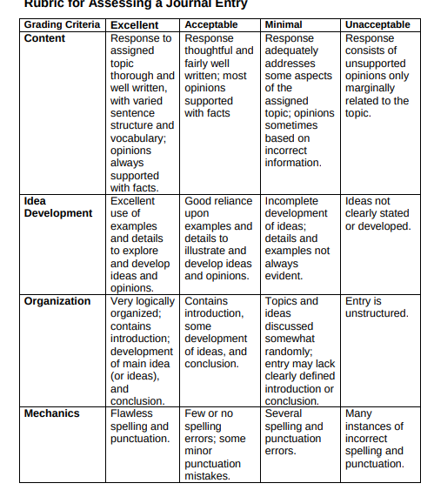
Journal Entry Rubric
Grading Scale
Excellent-5 points
Acceptable-4 points
Minimal-2 points
Unacceptable-1 point

Journal 1= /20 points

Journal 2= /20 points

Creative Artifact/Presentation

You will choose one of the following creative learning opportunities to complete and present to your peers. Each student will need to present and explain their project. This assignment allows individuals to demonstrate their creativity and oral communication skills.

Creative Artifact Options:
- Book Reveal-Google Slides/Powerpoint/Prezi (Create a Google Slides/Presentation about your book)
  - Be sure to include the following information:
    - Slide 1: title, author, publication date
Slide 2: brief plot outline of main events of the story
Slide 3: main character list complete with physical & personality descriptions
Slide 4: a detailed description of the setting
Slide 5: your favorite quote or part of the book with an explanation of why it’s your favorite
Slide 6: create a book review complete with 1-5 star rating and why
Slides 7-10: free choice slides
  - The presentation must also include: a colored theme for the slides (not plain white), pictures, etc.

- Comic Book Creation- Illustrate/design a three page comic book summary of your novel
  - Must include major events/characters and least four direct quotes from the novel
  - Either take and upload pictures/create the comic book on a digital platform that can be presented in front of the class

- Set the Scene- Using the program CoSpaces (or similar program) students will design an interpretation of environment/setting of their novel
  - Students will write a one paragraph analysis of their setting
  - Be sure to explain why you choose to include specific aspects (citing direct quotes from the novel)

- Newspaper- Create a digital newspaper that describes the major events of the novel.
  - Your newspaper must include the following elements: a news story, a book review, an interview with a character (feel free to add additional pages)
  - Use quotes from the books for your interviews and feel free to embellish where necessary as long as everything is in keeping with the novel.
  - Use text-based evidence such as quotations, symbols, themes, and situations to explain your choices.

- The Soundtrack- Make a 7-9 song playlist on Apple Music/Spotify/CD.
  - For each song or musical piece, provide an in-depth analysis that explains its connection to the novel (why you chose to include it on the playlist).
  - You should write a minimum of three sentences to describe/analyze each song.
  - Create a case cover for the CD/artistic design for the playlist. Be artistic and neat! It should look like something you bought at the store. (You could use an online design program such as Canva to create your cover)

- Compose and Perform an Original Song- Choose a character, event, or theme from the novel and create a song.
  - The lyrics should accurately reflect the details from the novel and the song should be at least two minutes long.
  - You need to provide a typed copy of the lyrics when you submit your project.
  - You must also perform in front of the class on the day the project is due.
  - The lyrics must be original (no copyright infringement).

- Movie Trailer- Create a unique movie trailer for your book that piques the interest of your peers. The trailer should be no shorter than 90 seconds and no longer than five minutes.
  - A hook to pique your audience’s interest (make us want to finish your trailer) Author and title of book Brief summary of the book (don’t give too much away)
  - One or two quotes from your book (these should be exciting, funny, or interesting)
  - Description of the setting
  - A “cliffhanger” element: a question to spark curiosity
  - Credits for images, audio (sound effects and/or music, and to you for creating the trailer)
  - Movie trailer is professionally edited (transitions should be smooth, audio clear, etc.)

Please be sure to continue to consider the following elements for each creative artifact:
- Make sure text size/font are easy to read
- Each artifact should be neat and organized appropriately
- Re-read the description and the rubric prior to submitting the assignment

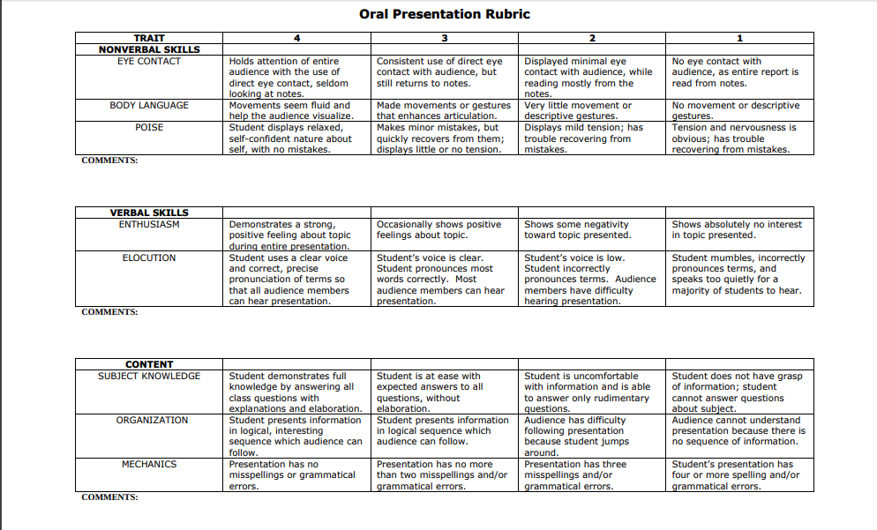

Score: /24 points

Creative Artifact Rubric

Category | Level 4 | Level 3 | Level 2 | Level 1
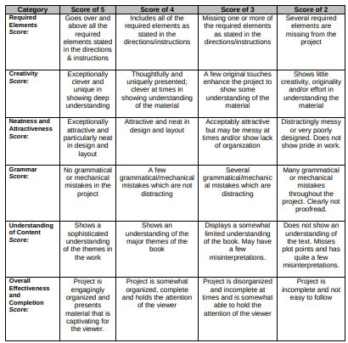
Score: /72 points

